AI STYLE GUIDE

Brought to you by Magnetic Communication by A. Carly Buxton
www.carlybuxton.com/magnetic

Instructions
Use AI. Keep your voice.

This guide exists to help you stay recognizable while using AI to write. AI handles fluency easily, but capturing your unique voice takes instruction and practice. Fill out this "AI Style Guide" to provide your LLM with guidelines about your stylistic quirks (and pet peeves), so that you can rely on AI without sounding like everyone else.

HOW TO USE THIS GUIDE

1. Fill out the pages of this style guide, deleting the examples provided so that only your own voice shines through.

Work through each section slowly and concretely. Specific language matters here.

2. Gather writing samples that sound like you.

Choose three to five short pieces that represent your natural voice on a good day.

Good candidates tend to be:
- something you wrote to explain or decide
- a project, memo, article you're proud of
- a blog post or long-form social post that reflects your reasoning process

Skip anything heavily edited by others or written with AI in the first place.

3. Use these materials to orient your AI.

Upload:
- this (completed!) style guide
- your selected writing samples

Then give a clear instruction about what you want the model to do with them.

A simple instruction works best: Use the attached style guide and writing samples as the reference for how I sound on the page.

I. MY VOICE PRINCIPLES
This is what stays consistent across platforms, formats, and tools

These 3-5 core qualities shape all of my authentic communication. (For each principle you include, write a one-sentence definition and add 1-2 concrete examples of what this sounds like in practice):

Example:
Clear - I state my point early and avoid ambiguity or euphemism.
Sounds like:
- “We need to decide today whether to delay the launch by two weeks.”
- Not: “There are a few considerations we might want to explore.”

MY VOICE PRINCIPLES ARE:

1.
2.
3.
4.
5.

These principles are my north star. Everything AI produces should be checked against these principles.

II. LANGUAGE PATTERNS TO AVOID
My pet peeve "AI tells"

This section points out the rhetorical and stylistic turns I'd like to avoid. When AI writes using these tropes, the result just doesn't sound like me.

Example:
1. Words or phrases that weaken clarity (such as vague openers, filler language)
2. Sentence patterns that imply logic without earning it (such as smooth transitions that aren't rooted in evidence or imply a causal link when one does not exist)
3. Professional language that feels inflated or jargon-y (such as buzzwords)
4. Politeness drift that undercuts authority (such as over-softening, excessive hedging)
5. Indefinite pronouns as sentence or clause subjects
6. Negative rhetorical reframes ("it's not about x, it's about y" or "A is more than B")

I AVOID THESE LANGUAGE PATTERNS:

1.
2.
3.
4.
5.

III. STRUCTURAL NORMS
How my ideas tend to "move" on the page

Example:
- Use HOPES (Hook, Overview, Points, Evidence, Strong Conclusion) as my go-to outline for delivering content
- Incorporate a variety of unexpected, vivid verbs that make people pause to savor

Here are 5-7 rules that govern how I typically shape my writing:
1.
2.
3.
4.
5.
6.
7.

IV. TONE BY CONTEXT
Same voice, different settings: This section coaches AI in the norms of your environment, your team, and your typical outputs.

Here is a list of my most common communication contexts.

CONTEXT 1:
Audience:
Tone:
Typical length:
What matters most:

CONTEXT 2:
Audience:
Tone:
Typical length:
What matters most:

CONTEXT 3:
Audience:
Tone:
Typical length:
What matters most:

CONTEXT 4:
Audience:
Tone:
Typical length:
What matters most:

V. UPLOAD THIS STYLE GUIDE TO YOUR PREFERRED LLM AND REQUIRE THAT IT BE CONSULTED EACH TIME YOU USE AI TO EDIT YOUR MESSAGING.
Remember: never use AI for brainstorm-engineering or construction of sentences (Steps 1 and 3).

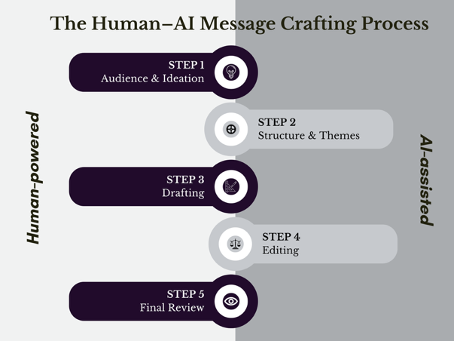

FINAL NOTE: THE HUMAN-IN-THE-LOOP RULE
Non-negotiable

Before anything goes out:
- Read it aloud once.
- Cut relentlessly, especially in professional contexts.
- Ask:
  - Would I really say this?
  - Would I stand behind this?
  - Does this sound like me on a good day?
  - If I dropped this paper on my way to share this idea, would I know what to say?

AI can help you work faster.
Only you can decide what’s worth saying.

